INSTRUCTIONS FOR AUTHORS: PREPARATION OF CONTRIBUTIONS FOR THE PROCEEDINGS MCC 2019 (FOR TITLE USE CAPITAL LETTERS, CENTERED, BOLD, TIMES NEW ROMAN, SIZE 12)
  - Name Surname ¹*, Name Surname ², Times New Roman, bold, size 12
  - ¹Name of University/ Company, Name of Faculty, Full address, Country,
² Name of University/ Company, Name of Faculty, Full address, Country,
*Corresponding address: e-mail: mail@mail.com
Times New Roman, Italic, size 12

Key words: Please provide 5 key words divided with commas - Times New Roman, size 12

This guide summarizes the instructions for authors who are going to submit their contributions in the form of extended abstracts (short papers) for publication in the Proceedings of II International Conference Materials, Ceramics and Composites 2019 in Varna, Bulgaria. The Proceedings will be distributed in electronic versions on pen drives.
The contributions should be written in English using Times New Roman (style Text) of size 12 and should not exceed 2 pages of A4 format (21×29.7 cm).
The margins are as follows:
- on even page: top - 2 cm, bottom - 2 cm, right side - 2 cm, left side - 3 cm;
- on odd page: top - 2 cm, bottom - 2 cm, right side - 3 cm, left side - 2 cm.
Please do not change the document settings and be wary when pasting elements into this template.

Header
Paragraph text - Times New Roman, size 12

Figures
Paragraph text - Times New Roman, size 12
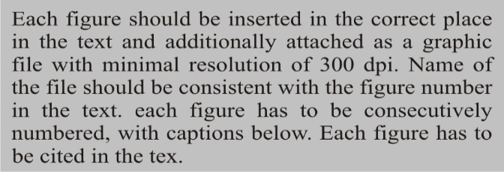

Figure captions Times New Roman, bold, italic, size 12

Tables
Paragraph text - Times New Roman, size 12

Table title Times New Roman, bold, size 12
Table content
Times New Roman, size 12

Equations
Equations should be inserted as Microsoft Word document equation:
(1)
If equations are numbered, make sure that they are numbered consequently. Put the numbers in parentheses flush with the right-hand margin level with the last line of the equation.

File type and size
A Microsoft Word file (.doc) is required. A total size should not exceed 8 MB.

Submission
The contributions to the II International Conference Materials, Ceramics and Composites 2019 Proceedings are to be submitted on-line through the Conference website www.mcc.foundry-conference.com/registration/. The deadline for submission is 31.05.2019. Submission after that date will not be possible. The name of the submitted file should include the surname of the first author and his/her affiliation. For any inquiries about the abstracts please contact: mcc@foundry-conference.com

Acknowledgments (optional)
Acknowledgements should be placed before references. Times New Roman, size 12.

References

Times New Roman, size 12.

References should be numbered consecutively.

References should be cited in the text in square brackets [1], [2,3], [4-6].
For books:

[1] Author(s). (Year of publication). Book title. Place of publication: Publisher.
For book chapters or articles in a book:

[2] Author(s) of chapter. (Year of publication). Chapter title. In Editors of the book (Eds.), book title (chapter page range). Place of publication: Publisher.
For proceedings from a conference:

[3] Author(s). (Year of publication). Title. In Conference name, date (page range). Place of publication: Publisher.
For thesis:

[4] Author(s). (Year of publication). Title. Place of publication.
For journal article:

[5] Author1, Author2 & Author3. (Year of publication). Article title. Journal title. Volume (issue), range of pages.

For patents:

[6] Author. (Year). Patent number. The location. Issue body.

For web pages:
[7] Author/Sponsor (last update or copyright date). Title. Retrieved date of access, from URL

